Announcing the Twin Forks Chapter ALL Steam Excursion behind the IMPRESSIVE Reading Steam Engine T1 2102!
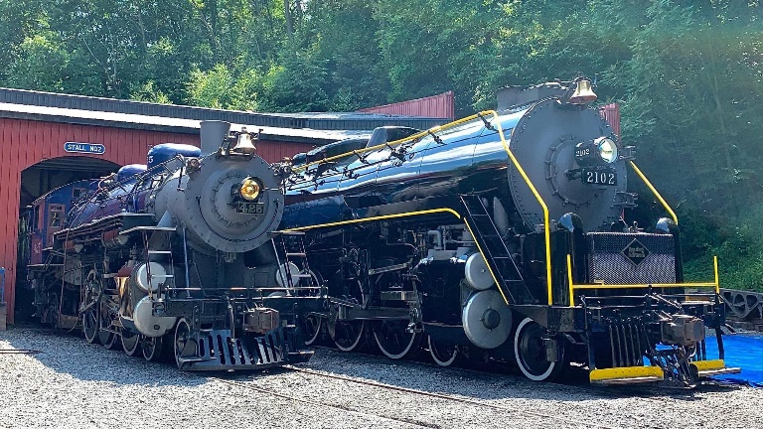
We will leave early in the AM on October 8, 2022 and travel to the Reading Blue Mountain & Readings Outers station. Here we will board our Steam excursion for a trip to Historic Jim Thorpe, PA.
After a layover at Jim Thorpe, we re-board our train back to Reading. The RBMN has promised a photo run-by during the trip as well. We will be riding behind the steam locomotive for almost 6 hours in total.
Your ticket to this steam train event includes
- Round trip transportations from Hicksville or Ronkonkoma to Reading and return
- All day excursion behind Reading T1 2102
- A photo run by during the trip
- Visit to the Historic village of Jim Thorpe
- Chance to photograph the trains and the Steam Locomotive during our lay over.
All you have to do is sit back relax and enjoy the day out with a big steam locomotive, beautifully restored by the RBM&N shop crews.
The trail cars we will be travelling in are complete with plush reversable seats, the coach will also have open windows to enjoy the Chugging sounds of Steam loco 2102 as she pulls more than 10 heavy passenger coaches.
PLEASE NOTE - Get your order in ASAP as these trips are selling out very fast. We only have a limited number of tickets available - so get yours today, don’t get left out!
You can contact us with any questions at twinforksnrhs@gmail.com
Twin Forks 2022 All Steam Excursions Order Form
Tickets for this steam event are inclusive as listed above
This Steam excursion is open to ANYONE who would like to join us. All ages invited
ALL ARE WELCOME!
Yes, I want to order _____ Members Tickets ($150pp) _____ Non-Members Tickets ($170pp), for a total of $_____________________.
Name: _________________________________ Phone: _____________________
Address: ___________________________________________________________
City: ____________________________________ State: ______ Zip : __________
Email Address: ______________________________________________________
Emergency Contact: ____________ Phone: ___________ Relation:____________
Pickup Point: __ Ronkonkoma Railroad Station __ Hicksville Railroad Station

Payment Option 1 – Check:
Please make checks payable to
Twin Forks Chapter NRHS
PO Box 1620 Ronkonkoma NY 11779

Payment Option 2 – Credit Card:

To pay by credit card, please fill out the form below and mail to the address listed above, or send the information to twinforksnrhs@gmail.com.
Name on Card: ____________________________________________________________
Card Number: _____________________________________________________________
Card Type: __________________ Expiration date: __/__ Security Code: _________
Note- First come first serve, limited number of tickets assigned to us, excursion runs rain or shine. The RBM&N reserves the right to alter consist and motive power. No refunds please.

